Definition and Usage :-

The display property specifies the display behaviour (the type of rendering box) of an element.

Syntax:

Display: Value;

1. Display: Block;

* 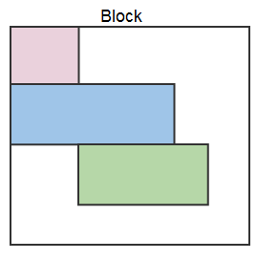Displays an element as a block element. It starts on a new line, and takes up the whole width

1. Display: Inline;

* Displays an element as an inline element. Any height and width properties will have no effect

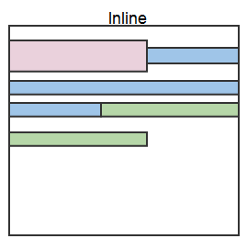

1. Display: Flex;

* Displays an element as a block-level flex container

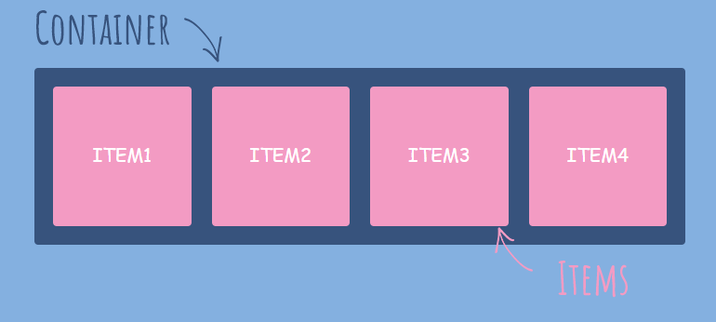

1. Display: Grid;

* Displays an element as a block-level grid container

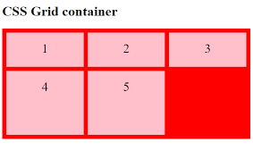

***USE:***

* **Display: Block;**
* It Act as Block level tag

Like

* <div>
* <h1> - <h6>
* <p>
* <header>
* <footer>
* <section>
* **Display: inline;**
* It aligns the item in line
  + - * Ex.

Just like the <Li> Display vertical,

But using ***inline*** we can arrange in a Horizontal position.

* + - * + **Display: Flex;**
        + The Flexible Box Layout Module, makes it easier to design flexible responsive layout structure without using float or positioning.
        + **Display: Grid;**
        + The CSS Grid Layout Module offers a grid-based layout system, with rows and columns, making it easier to design web pages without having to use floats and positioning.
        + We can also define an area by giving it a name and then specify the location of that area in the value of the grid-template-areas property.